BOWMANVILLE ARCHERS PATHFINDERS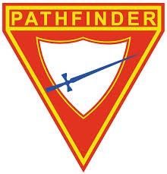
Club Registration Fees

Registration fees cover the 10-month Pathfinder Club year. This includes club registration with the Ontario Conference of the Seventh-day Adventist Church, club insurance, uniform insignias, class workbooks and supplies, club pins, investiture awards/patches, type-B uniform, scarf, club trips and more. Camping trips will have additional fees.

Returning/transferring club members may need to buy extra uniform pieces they have outgrown/missing. Uniform prices will be added to your registration fee.
(See Uniform Order Form)

REFUNDS DEADLINE: No refunds of any kind will be issued after the last Sunday of September.

 | Returning Members | New Members
1st CHILD NAME: | $95 | $110
2nd CHILD NAME: | $80 | $90
3rd CHILD NAME: | $70 | $75
4th CHILD NAME: | $45 | $50

- Please download our Parent Handbook from our website.

PAYMENT OPTIONS

  - Pay your registration fee anytime with your weekly tithe envelope in church. Mark “Other” as Pathfinder Registration
  - Pay in person at our first club session.
3. All monies must be completed by the first Sunday in October. No outstanding account beyond the deadline.
4. Subsidy and/or sponsorship may be available for families with financial difficulties. Please contact the club director.
Note: Cheques payable to Bowmanville Seventh-day Adventist Church. Memo: Pathfinders

